Test Project

Module 3
  - WSC2015_TP40_M3_ID

Names: Weixiong Xu, Sathish Narayanan, Wolfgang Toechterle, Ivs Zenne, Sherein Abdel-Al, Hazem Taha, Ahmed Al-Harrasi, Patricia Dupuis, Brian Dupont, Susan de Guzman, Thomas Palacin

Contents

This Test Project proposal consists of the following documentation/files:
WSC2015_TP0X_V10_Packaging_EN.docx
Skill40_Packaging (folder containing all the supplied elements (i.e images, logos, texts, etc.)

Introduction

Project: Design a package, sticker and booklet.

Description: The Company Prija would like to create and design a package in order to present three of their products in a new and interesting way.
The three products you will include are:
- Relaxing Massage Lotion with Cypress Aromatherapy
- Softening soap
- Hygienic set

Prija would like to distinguish their products from other competitor products in the Hotel suppliers market.

Prija makes products including: Shampoo, shower gel, soap and body lotion
for hotels and tourist accommodation.
The company slogan is: Exclusive hotel cosmetics with a touch of luxury.

Environmental protection and sustainability are very important to Prija.
The manufacturer of the cosmetic products is subject to strict regulations
related to environmental protection. The bottles and the packaging are made
with recyclable material.

Due to popular demand, Prija have extended their product range and now offer an exclusive range of hotel cosmetics. This range offers various fragrances, product lines and cosmetic brands and the ingredients are based on organic plants and spices from Asia.

Perusahaan Prija ingin membuat dan design sebuah package untuk menyajikan tiga produk mereka dengan cara yang baru dan menarik.
Ketiga produk Anda akan mencakup adalah:
- Relaxing Massage Lotion dengan Cypress Aromatherapy
- Softening soap
- Hygienic set

Prija ingin membedakan produk mereka dari produk pesaing lainnya di pasar Hotel suppliers.

Prija membuat produk termasuk: Shampoo, shower gel, sabun dan body lotion yang diperuntukan bagihotel dan tourist accommodation.
Slogan dari perusahaan Prija adalah: Exclusive hotel cosmetics dengan sentuhan mewah.

Perlindungan lingkungan dan keberlanjutan sangat penting untuk Prija.
Produsen dari produk kosmetik taat pada peraturan yang ketat yang berkaitan dengan perlindungan lingkungan. Botol dan kemasan yang dibuat dengan bahan daur ulang.

Karena permintaan yang banyak, Prija telah memperluas jangkauan produk mereka dan sekarang menawarkan berbagai eksklusif kosmetik hotel. jangkauan produk ini menawarkan berbagai wewangian, lini produk dan merek kosmetik dan bahannya dibuat berdasarkan pada tanaman organik dan rempah-rempah dari Asia.

Design: The package design should appear elegant and natural to emphasise the organic extracts, beneficial properties and natural ingredients. The products are high quality, luxurious and should appeal to a moderate-high income demographic.

Desain kemasan harus tampil elegan dan alami untuk menekankan kepada ekstrak organik, manfaat dari produknya dan bahan-bahan alami. Produk ini berkualitas tinggi, mewah dan harus menarik bagi demografis yang pendapatan sedang-tinggi.

Target market: Adults aged 30 – 60 years who enjoy nature with a touch of luxury.
Orang dewasa berusia 30 - 60 tahun yang menikmati alam dengan sentuhan mewah

Instructions to the competitor

Create a folder on your Desktop called YY_MOD3 (where YY represents the number of your workstation).
This folder must include the following subfolders “Task 1, Task 2, Task 3”.
The subfolders are to contain two folders:
- A folder named “Original”: it should contain all the files used for the development of your project.
- A folder named “Final”: it should contain all of the files you are supposed to deliver as required in
the tasks. (PDF, native, fonts and linked images)
- You must include (memasukkan) your workstation number on the presentation board and printouts for marking and delivery to your workstation

About image marking for all tasks:
The colour mode and file formats of your images will be evaluated in the press ready pdf files. The final resolution will be assessed in your working software, such as Illustrator or InDesign.
The .JPG / .PNG file format is NOT ACCEPTED for images. Only the following file formats are acceptable TIF / .EPS / .AI / .PSD / DSC 2.0

Time limit for this test project: 6h

Description of project and tasks

TASK 1
Sticker design
Design a sticker to be stuck onto the package design. It will be used for promoting Hotels that use Prija
products. Every Hotel using Prija products can display their own logo on the package via this sticker so the hotel can be proud to include the package in the guest rooms.

Desain stiker yang harus dimasukkan ke dalam the package design. package design ini akan digunakan untuk mempromosikan Hotel yang menggunakan produk Prija. Setiap Hotel yang menggunakan produk Prija dapat menampilkan logo hotel mereka sendiri di the package melalui stiker ini, sehingga hotel yang menggunakannya bangga menyediakan the package di guest rooms.

Elements on the sticker
• You may create your own illustrations for the sticker design
• Include the Sticker Text on the sticker (“Mod3_Text.docx”)
• Include the Hotel logo on the sticker (“Mod3_Logo_HolidayInn”)

Technical specifications
Dimensions: A minimum of 40mm (wide or high) (lebar atau tinggi)
Bleed (if necessary): 3 mm
Colours: 2 pantone coated colours and one dieline plate (named: dieline)
Printing: printed on one side only
Trapping (if necessary): 0.4 pt
The sticker must be vector only

You must deliver
• Folders as specified in “Instructions to the Competitor” on page 4.
Only files from these folders will be assessed
• 1 final composite PDF/X-4:2008 file (including bleed and die line only).
• 1 printout at 100% on A4 with bleed, die line, colour bars and registration marks only.
• 1 printout trimmed to size and mounted on an A4 board.

TASK 2
Design a package to hold 3 different beauty products.
The three products must fit into one package and each product differs in shape and volume. The package must be an appropriate size for the products.
Ketiga produk ini harus dapat masuk ke dalam satu package dan setiap produk yang akan masuk berbeda dalam bentuk dan volume. The package harus memiliki ukuran yang sesuai untuk produknya.
You must choose one of the following options (Anda harus memilih salah satu dari pilihan berikut):
A) have at least one, to a maximum of two products protrude out from the package (the products must protrude out from your package no more than 50%). (memiliki minimum satu hingga maksimum dua produk yang menonjol keluar dari The package (produknya harus menonjol keluar dari The package tidak lebih dari 50%)).
OR
B) you must have a clear window to show the products from the outside of the package. At least one, to a maximum of two products must show through the window (no more than 50%). (Anda harus memiliki jendela yang bolong untuk menunjukkan produk dari luar The package. Minimum memiliki satu hingga maksimum dua produk yang harus terlihat melalui jendela tersebut (tidak lebih dari 50%)).
For further information, refer to: Mod3_50%.pdf (Untuk informasi lebih lanjut, lihat: Mod3_50%.pdf)

These elements must be included in your package design
• LogoType: “Set your Beauty”
• Text supplied: “Mod3_Pack-Text.docx”
• Logos to be included in Vector-Format only:
- Manufacturer’s logo (Prija): Include the complete (Text + symbol of “Mod3_manufacture_Logo”)
- FSC (“Mod3_FSC_Logo”)
- RECYCLE (“Mod3_RECYCLE_Logo”)
• Images: Use a minimum of two supplied images on your package design (Mod3_Pack Images), you may edit the images according to your design, however, they must remain raster
• The client has specified that the background of the package must not be white
• The package must have at least two glue areas

Technical specifications
Max dimensions of die line: 297mm X 420 mm (A3 flat)
Max dimensions of inlay die line: If required — 210mm x 297mm (A4 flat)
(to secure the products inside the package)
(Inlay artinya struktur tambahan yang diperlukan yang menjaga produk untuk tetap berdiri sebagai mana harusnya)
Bleed for die line (if necessary): 3 mm
Colours: CMYK + 1 die line plate (named: dieline)
(cut, fold lines and glue areas must be differentiated in appearance, but all must be on the same die line plate) (cut, fold lines and glue areas harus dibedakan sesuai bentuknya, tetapi semua harus pada plate die line yang sama)
Printing: printed on one side only
Greyscale and colour image resolution: 200 – 280 PPI
Bitmap image resolution: 600 – 900 PPI
Note: You MUST NOT embed images in Illustrator or InDesign

You must deliver
- Folders as specified in “Instructions to the Competitor” on page 4.
Only files from these folders will be assessed
- 1 final composite PDF/X-4:2008 file: including die line on one separate spot colour plate, bleed, colour bars and registration marks only (and an additional file for the inlay, if required) (dan file tambahan untuk inlay, jika diperlukan).
- 1 printout of your design at 100% on A3 (including the die-cut)
- 1 final 3D mock-up at 100% of the final size

TASK 3
Booklet Design (the booklet will be included inside the package).
The booklet includes a description of the selected products and a short introduction to Prija products.
The booklet should serve to additionally advertise the products.
booklet ini mencakup deskripsi dari produk yang dipilih dan pengenalan singkat untuk produk Prija.
booklet ini harus berfungsi untuk memberikan iklan tambahan mengenai produknya.

• Design a small double-sided booklet that will be included inside the package.
• You may use any of the supplied images to include in your booklet design
and/or create your own illustrations
• Include the text on the booklet (“Mod3_Text.docx”).
• Include the vector manufacturer’s logo “Prija” on the booklet.
• Use your LogoType from Task 2: “Set your Beauty”

Technical specifications
Dimensions: A4 maximum flat — double sided.
Bleed (if necessary): 5 mm
Colours: 2 pantone uncoated colours
Folds (if required): Folds must be indicated using one of the pantone uncoated colours
Printing: sheetfed offset printing, double sided
Greyscale and colour image resolution: 280 – 300 PPI
Bitmap images resolution: 800 – 1200 PPI

You must deliver
- Folders as specified in “Instructions to the Competitor” on page 4.
Only files from these folders will be assessed
- 1 final composite PDF/X-4:2008 file (including bleed, colour bars, crop marks, registration marks and fold lines) Place your fold lines outside the bleed area in one of the pantone uncoated colours.
- 1 double sided printout at 100%, with bleed, crop marks and fold lines ONLY
- 1 double sided printout at 100%, trimmed to size and mocked-up (folded — if necessary)

Text

Package Text

Set your Beauty

Relaxing Massage Lotion with Cypress Aromatherapy
Softening Soap
Hygienic Set

www.prija.com
Prija Hotel cosmetics — an Italian company

Text for sticker:

www.holidayinn.com
+39 0471 634559

Booklet Text

Prija. Set your Beauty. This is a variety of high quality products created without any parabens, silicones and artificial colourings. All cosmetics contains the organic Ecocert certification and the Cosmebio label and include highly moisturising ingredients.

Environmental protection and sustainability are very important to us. The manufacturer of our cosmetic products is subject to strict regulations related to environmental protection.
The bottles and the packaging are made with recyclable material.

There is a complete collection of Prija products to collect including gift and travel packs. Prija has an earthly spirit, for those who like warm, contemporary, but not clinical cosmetics.

PRIJA relaxing massage lotion with aromatherapeutical cypress
Bottle in PET 40 ml
This is the ideal product for deep tissue and physical therapy work. This massage lotion provides the most friction with the least amount of slip and glide.
Prija luxury massage lotion is hypoallergenic and can also be used as a superb body lotion. It contains cypress and macadamia nut oil with extraordinary skin-softening properties. The product contains the finest ingredients and natural, exotic aromatherapy scents.

Application
Conditions and soothes your skin. Use after Relaxation Bath Salts or Relaxation Shower Gel.

Ingredients
Aqua, sodium laureth sulfate, fine ingredients and exotic fragrances.

PRIJA Softening Soap and Hygienic Set
A very high quality, wrapped soap in a recycled box. This soap is made from natural plant extracts. The Ginseng extract will revitalise and energise your skin. This soap has a smooth action and comes with high content of natural glycerin.

PRIJA Hygienic Cotton Set with Cotton Balls & Buds
Made of 100% organic cotton.

Made in China, EU-certified and dermatologically tested.
Produced by GFL according to very high quality standards for customers who are sensitive to the quality of cosmetic products and ingredients.

Package infO
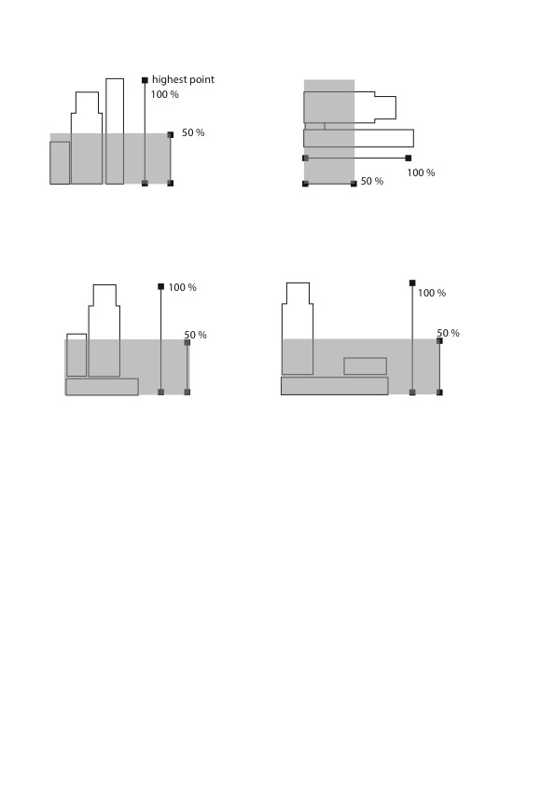

These are some examples, but your design can be different

